UNIVERSITY OF AGRICULTURE FAISLABAD
ER-D PROJECT
SUBMITTED BY:

STUDENT NAME: QURAT UL AIN
REGISTRATION NO: 2023-ag-9777
DEGREE: BS BIO-INFORMATICS
DEPARTMENT: COMPUTER SCIENCE
COURSE CODE: CS-408
COURSE TITLE: DATABASE MANAGEMENT SYSTEM

SUBMITTED TO:
MAM WAJEEHA AZMAT

- E-R DIAGRAM:

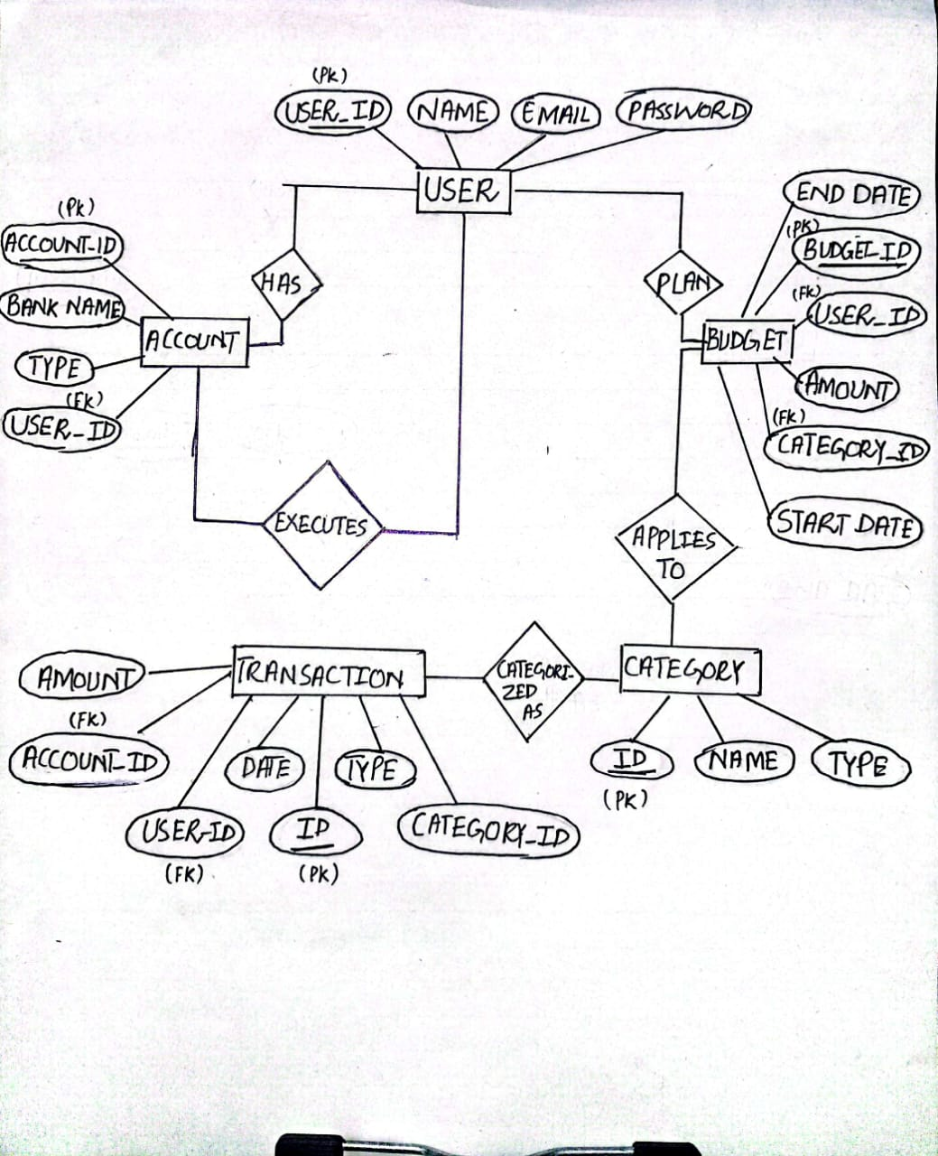

- TABLE FORMATION:

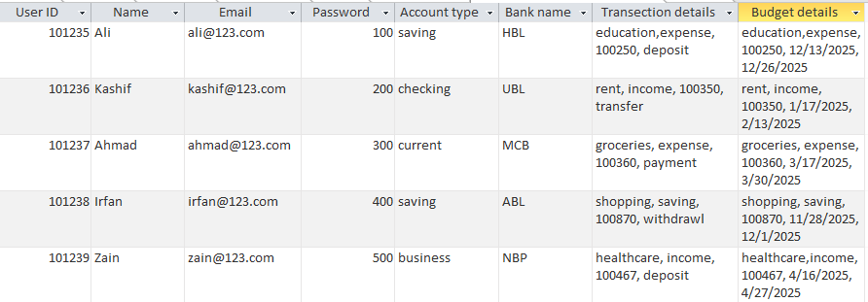

- FIRST NORMAL FORM:

- TABLES:
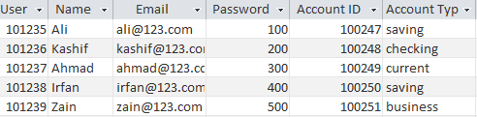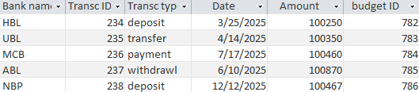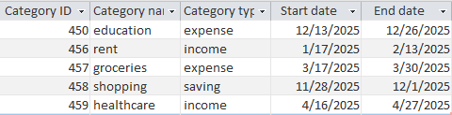
- PRIMARY KEY: USER ID
- (it is a single table because of space shortage I put it into parts)

- SECOND NORMAL FORM:

- TABLES:

- USER:

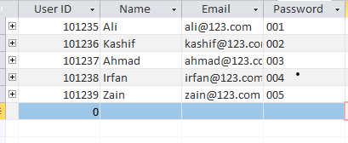
- PRIMARY KEY: USER_ID

- TRANSCRIPTION:

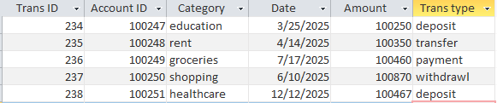
- PRIMARY KEY: TRANS_ID
- FOREIGN KEY: ACCOUNT_ID

- ACCOUNT:

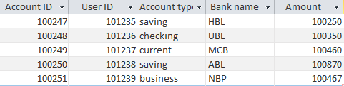
- PRIMARY KEY: ACCOUNT_ID
- FOREIGN KEY: USER_ID

- BUDGET:

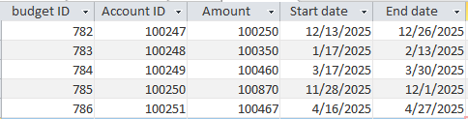
- PRIMARY KEY: BUDGET_ID
- FOREIGN KEY: ACCOUNT_ID

- REALTIONSHIPS:

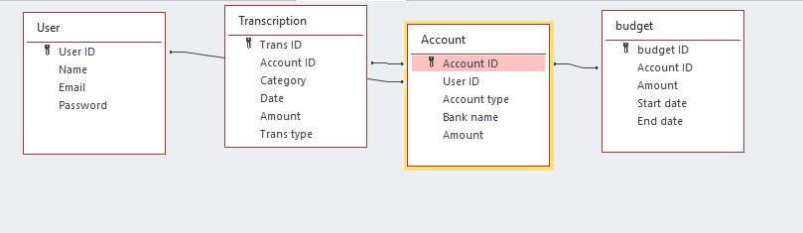

- THIRD NORMAL FORM:

- TABLES:

- USER:


- PRIMARY KEY: USER_ID

- TRANSACTION:

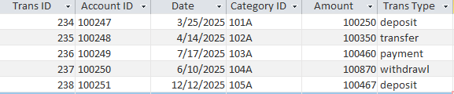
- PRIMARY KEY: TRANS_ID
- FOREIGN KEY: ACCOUNT_ID

- ACCOUNT:

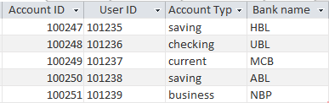
- PRIMARY KEY: ACCOUNT_ID
- FOREIGN KEY: USER_ID
- CATEGORY:

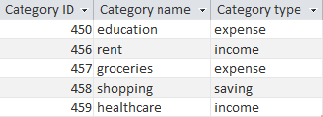
- PRIMARY KEY: CATEGORY_ID

- BUDGET:

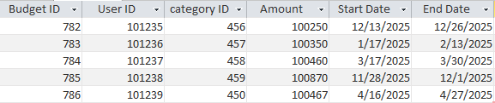
- PRIMARY KEY: BUDGET_ID
- FOREIGN KEYS: USER_ID, CATEGORY_ID

- RELATIONSHIPS:

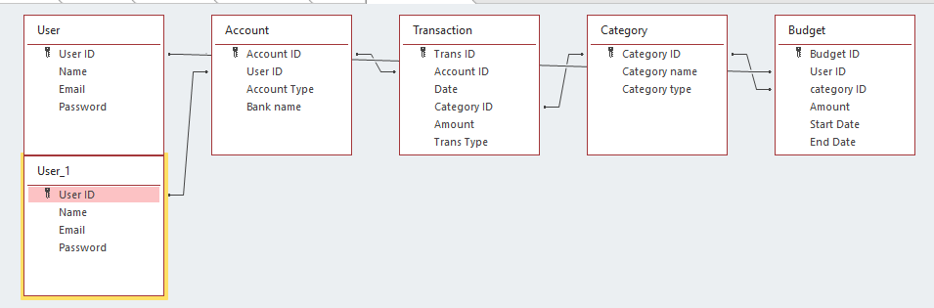

- FORMS:

- USER:

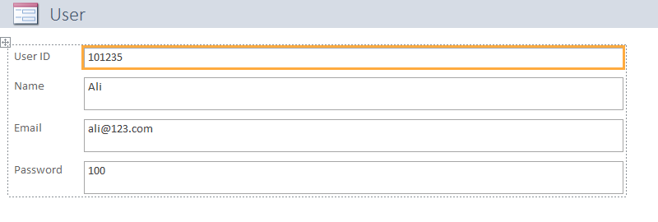

- TRANSACTION:

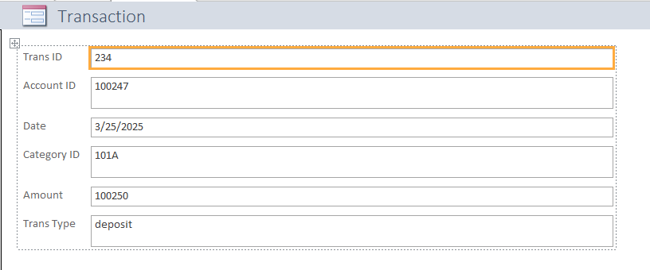

- ACCOUNT:

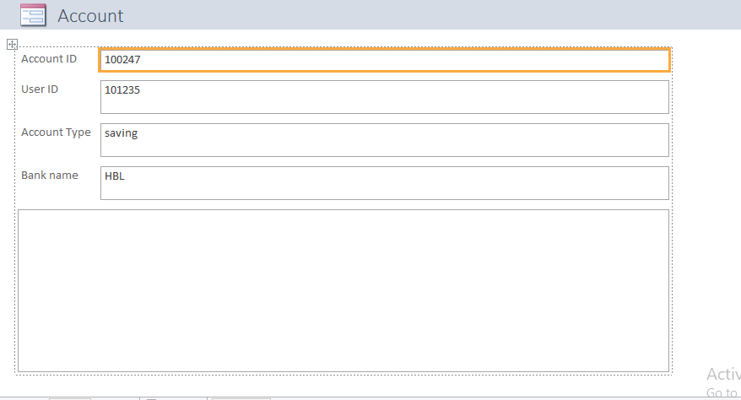

- CATEGORY:

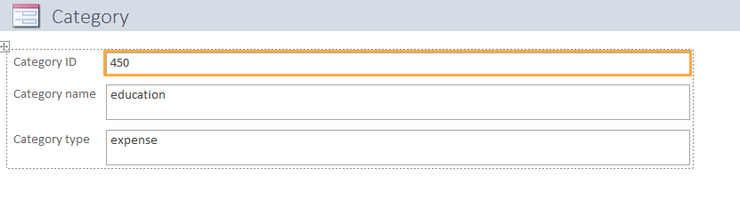

- BUDGET:

